**Response, Level F1, Nana Upstairs and Nana Downstairs**

The teacher asked the students to choose a passage from the text that was important to them or had special meaning to the writer. This child chose a double-entry log to respond to Tomie de Paola’s Nana Upstairs and Nana Downstairs. The book’s selected passage is on the left.

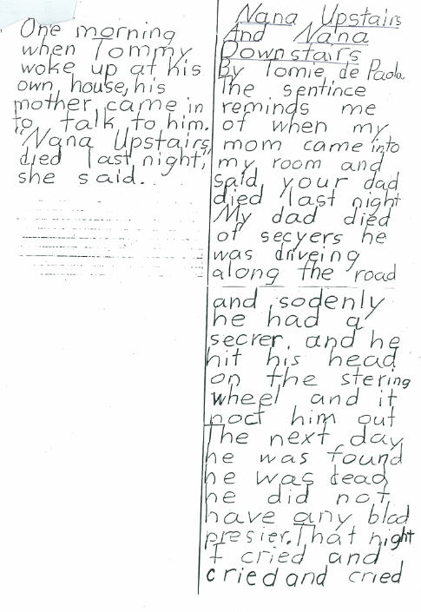

|  |  |
| --- | --- |
| One morning when Tommy woke up at his own house, his mother came in to talk to him. “Nana Upstairs died last night,” she said. | Nana Upstairs and Nana Downstairs by Tomie de Paola  The sentence reminds me of when my mom came into my room and said, “Your dad died last night.”***(Complex sentence with compound verb in the dependent clause and dialogue)***  My dad died of seizures. ***(Simple sentence)*** He was driving along the road, and suddenly he had a seizure. ***(Compound sentence)***  ***Can you find the subjects and verbs in the remaining sentences?***  And he hit his head on the steering wheel, and it knocked him out. ***(Compound sentence; the first “And” isn’t needed)*** The next day he was found. He was dead. He didn’t have any blood pressure. ***(Simple sentences)***  That night, I cried and cried and cried. (***Simple sentence with compound verbs)*** |